Afr-Egy-Hathor-Bronze-Figurine

Hathor bronze figurine, 2.5"W x 2.75"H

*from a large estate sale of a late, affluent, world traveler from a historic section of West Hartford CT. Many of the antiques, oddities, and collectibles were acquired during a lifetime of global travel and collecting. Items will be described to the best of our ability. For more treasures from this collection please* [*click here*](http://search.ebay.com/?sass=phins_81&ht=-1)*!*

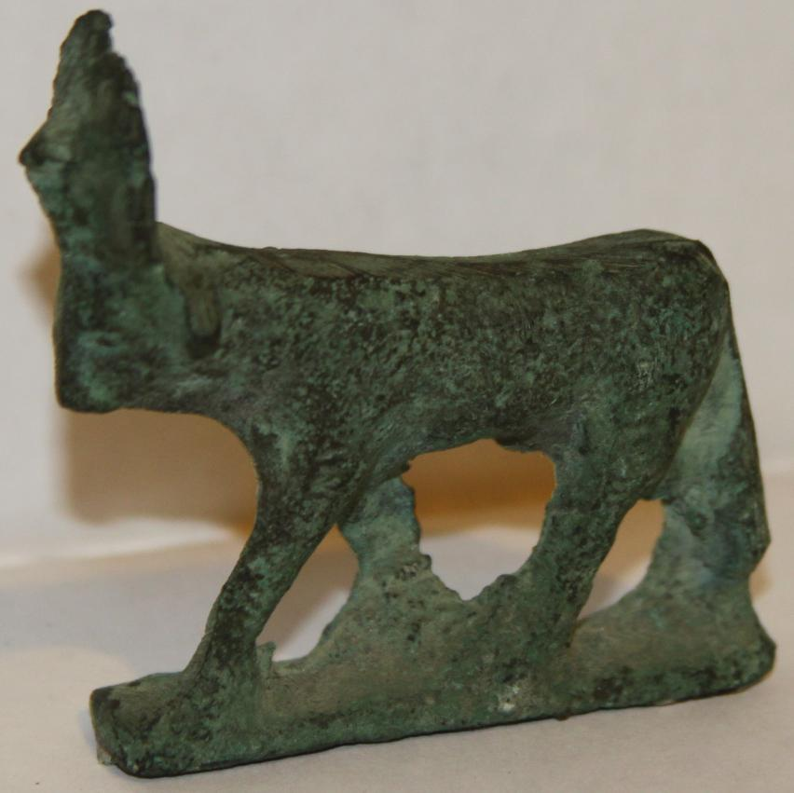

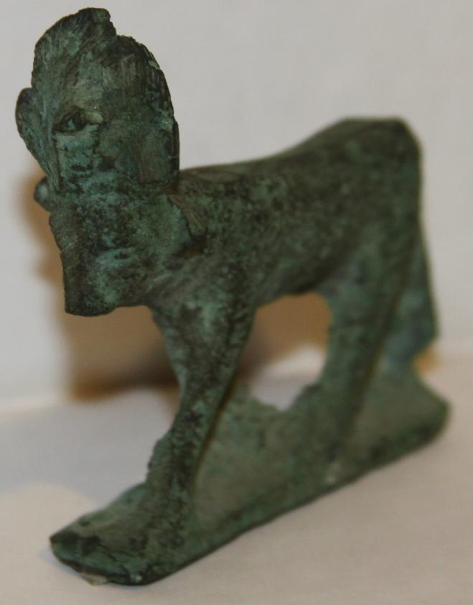 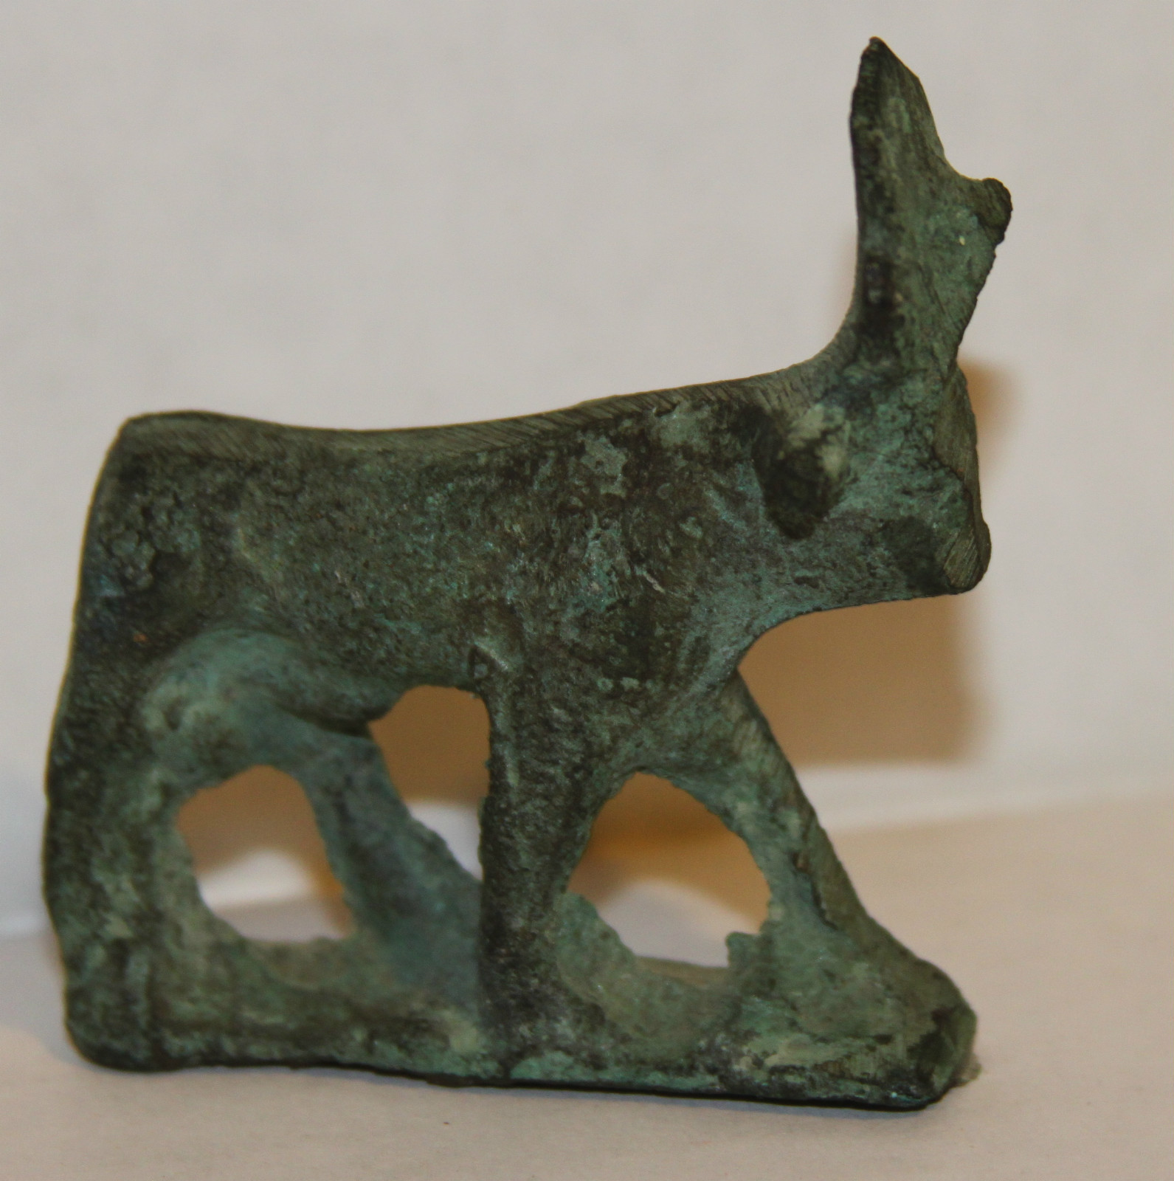 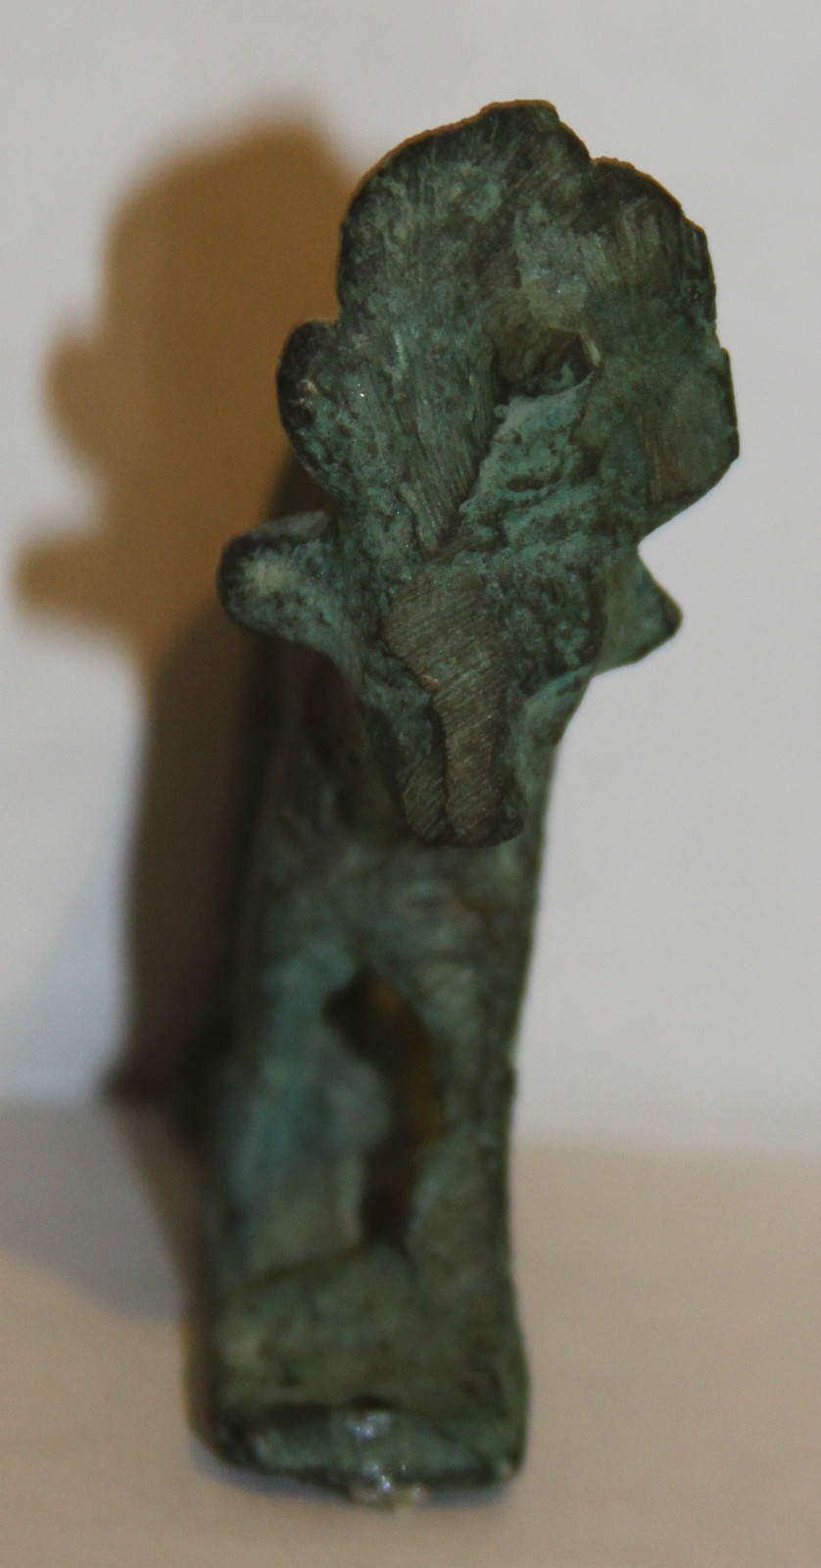

|  |
| --- |
| Shipping details |
| **Ralph J Coffman Jr**  149 Atlantic Ave  Swampscott MA 01907-2427  United States |

## Order details

|  |  |  |  |
| --- | --- | --- | --- |
| **Item title** | **Available actions** | **Shipping & handling (estimated delivery*)** | **Price** |

[Printer version](http://payments.ebay.com/ws/eBayISAPI.dll?ViewPaymentStatus&transid=0&userloginid=802-867&orderid=125015167016&printerversion=true&itemid=230898290908)

|  |  |  |
| --- | --- | --- |
| Seller: | [**Member id** phins_81](http://myworld.ebay.com/phins_81) ( [**Feedback Score Of** 520](http://feedback.ebay.com/ws/eBayISAPI.dll?ViewFeedback&userid=phins_81)) | [Contact seller](http://contact.ebay.com/ws/eBayISAPI.dll?ShowCoreAskSellerQuestion&frm=3998&iid=0&redirect=0&requested=phins_81) |

|  |  |  |  |  |
| --- | --- | --- | --- | --- |
| **Order # 125015167016**  Paid on Dec-23-12 via PayPal | | | | |
|  |  | |  | | --- | |  | | |  |  | | --- | --- | | [Contact seller](http://contact.ebay.com/ws/eBayISAPI.dll?ShowCoreAskSellerQuestion&frm=3998&iid=230898290908&redirect=0&requested=phins_81) |  | | |  |  |

|  |  |  |  |  |  |  |  |
| --- | --- | --- | --- | --- | --- | --- | --- |
| [**Item Title:**Ancient Egyptian ISIS & NEFERTARI Hieroglyphic Plaster Relief Slab Cairo 12x25 **- opens in a new window or tab**](http://cgi.ebay.com/ws/eBayISAPI.dll?ViewItem&item=230898290908)  **Item Id:**230898290908 - Price: US $69.95  Quantity:1  **eBay note:**  Having a problem with this purchase? [We can help](javascript:;) | |  | | --- | |  | | |  |  | | --- | --- | | [Leave feedback](http://feedback.ebay.com/ws/eBayISAPI.dll?LeaveFeedbackShow&useridfrom=802-867&useridto=phins_81&item=230898290908&transactid=0) |  | | | Standard Shipping: **US $28.68**  Estimated delivery: December 28 - January 4 | US $69.95 |
| [**Item Title:**Ancient Egyptian Goddess HATHOR Hieroglyphic Plaster Relief Slab Cairo 9x20 **- opens in a new window or tab**](http://cgi.ebay.com/ws/eBayISAPI.dll?ViewItem&item=230898290909)  **Item Id:**230898290909 - Price: US $49.95  Quantity:1  **eBay note:**  Having a problem with this purchase? [We can help](javascript:;) | |  | | --- | |  | | |  |  | | --- | --- | | [Leave feedback](http://feedback.ebay.com/ws/eBayISAPI.dll?LeaveFeedbackShow&useridfrom=802-867&useridto=phins_81&item=230898290909&transactid=0) |  | | | Shipped with item above | US $49.95 |

|  |  |  |  |  |  |  |  |
| --- | --- | --- | --- | --- | --- | --- | --- |
| [**Item Title:**ANTIQUE SOLID BRONZE Deer Ungulate Animal Hand Carved Sculpture - Patina**- opens in a new window or tab**](http://cgi.ebay.com/ws/eBayISAPI.dll?ViewItem&item=230898300819)  **Item Id:**230898300819 - Price: US $4.95  Quantity:1  **eBay note:**  Having a problem with this purchase? [We can help](javascript:;) | |  | | --- | |  | | |  |  | | --- | --- | | [Leave feedback](http://feedback.ebay.com/ws/eBayISAPI.dll?LeaveFeedbackShow&useridfrom=802-867&useridto=phins_81&item=230898300819&transactid=0) |  | | | Shipped with item above | US $4.95 |



**Payment Instructions:**

I took $4+ off the Hathor s/h and 100% off deer sculpture s/h for you.

Thank you

|  |  |  |  |  |
| --- | --- | --- | --- | --- |
|  | | |  | |
|  |  | |  |  |  |  |  |  |  |  |  |  |  |  |  |  |  |  |  |  | | --- | --- | --- | --- | --- | --- | --- | --- | --- | --- | --- | --- | --- | --- | --- | --- | --- | --- | | |  | | --- | | |  |  |  |  |  |  |  |  |  |  |  |  |  |  |  | | --- | --- | --- | --- | --- | --- | --- | --- | --- | --- | --- | --- | --- | --- | --- | | |  |  | | --- | --- | | Subtotal: | US $124.85 | |  | | | Shipping & handling: | US $28.68 | |  | | |  | | |  | | | Total: | US $153.53 | | | | | |  |